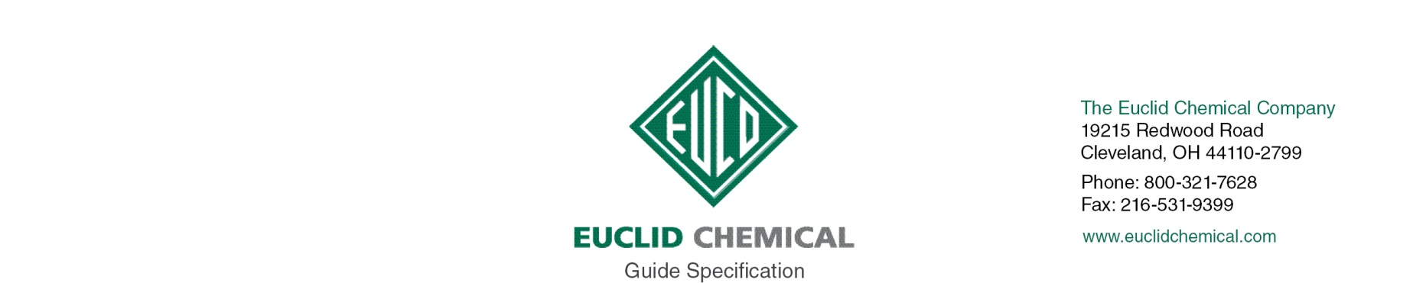
ULTRAGUARD
{Note to Specifier: This add-in specification component specifies Euclid Chemical Company, ULTRAGUARD Protectant for Concrete Floors}

ULTRAGUARD is a water-based polymeric protectant that improves the appearance and durability of concrete floors. ULTRAGUARD contains a powerful stain-resistant additive and is further enhanced with lithium silicate, which provides densification of the concrete surface. ULTRAGUARD can be used alone or in combination with a reactive sealer such as UltraSil Li+ to give concrete floors a glossy finish, harder surface, and protective seal.

{Note to Specifier: The paragraphs below are meant to be incorporated into Parts 2 and 3 of a standard CSI 3 Part Format specification, project’s General Structural Notes or directly onto the plans. They must be carefully reviewed by a qualified design professional and edited to meet the particular requirements of the project at hand, assure compliance with any governing building codes, and coordinate with other specification sections and drawings.}

1.1 QUALITY REQUIREMENTS

A. Manufacturer: ISO 9001 quality certified as primary manufacturer of specified products.

1.2 INFORMATIONAL SUBMITTALS

A. Product List: List manufacturer name and product name for each product proposed for use as concrete admixture and surface treatment.

B. Manufacturer Certificate: Indicating products listed on Contractor's Product List are compatible and suitable for the specified application.

PART 2- PRODUCTS

2.1 MANUFACTURERS

A. Manufacturer: Provide listed products of Euclid Chemical Co., Euclid, OH; www.euclidchemical.com.

B. Manufacturer Single Source: Provide micro-film concrete sealer compound and related concrete treatment and admixture products from a single qualified manufacturer.

2.2 LIQUID FLOOR TREATMENTS

A. Micro-Film Concrete Sealer: Water based polymeric sealer, minimum 20% solids, containing stain resistant additive, and densifying characteristics of lithium silicate.

1. Basis of Design Product:
a) “UltraGuard” by The Euclid Chemical Company

PART 3- EXECUTION

3.1 EXAMINATION

{Note to Specifier: Retain this Article when applying liquid micro-film sealer to existing concrete surfaces.}

A. When used on existing concrete, examine concrete surfaces to receive micro-film sealer. Notify specifier if surfaces do not comply with manufacturer's recommendations. Do not begin surface preparation or application until unacceptable conditions are corrected

3.2 PREPARATION

A. When used on existing concrete, prepare concrete surfaces in accordance with manufacturer’s written instructions.
1. Ensure surfaces are clean, dry and free of standing water.
2. Remove dirt, dust, oil, grease, sealers, and other materials that may prevent adhesion of micro-film sealer.

3.3 APPLICATION

A. Micro-Film Concrete Sealer: Dilute product 1:1 with water and apply to polished concrete surface per manufacturers recommendations at coverage rate of approximately 2,000 sq. ft. per gallon. Buff with High Speed Burnisher and soft buffing pad to achieve high sheen.

